IoT-based Battery Health Management System for Electric Vehicles: A Predictive Approach

Shamila, M.   
*Dept. of CSE (AI & ML), GRIET, Hyderabad, India*  
Email: shamila.m@gmail.com ORCID: 0000-0001-9105-9531

Sunkara Yaswanth  
*Dept. of CSBS, GRIET, Hyderabad, India*  
Email: yaswanth22245a3206@ grietcollege.comNamala Eshwar   
*Dept. of CSBS, GRIET, Hyderabad, India*  
Email: eshwar21241a3237@ grietcollege.com

R. P. Ram Kumar  
*Dept. of CSE (AI & ML), GRIET, Hyderabad, India*  
Email: rprkvishnu@gmail.com  
ORCID: 0000-0001-5687-977X Pichewar Somnath  
*Dept. of CSBS, GRIET, Hyderabad, India*  
Email: somnath21241a3244@ grietcollege.com

*Abstract*—The Electric Vehicle (EV) revolution is rapidly reshaping the automotive industry offering alternative to combustion engine vehicles. A cornerstone of this transformation is the lithium-ion battery, which powers these EVs. The possibility of battery failures leading to explosions and substantial losses is a critical concern that demands innovative solution. The primary objective of the Battery Health Management and Fault Predictive System (BHMFPS) is to enhance the safety and reliability of electric vehicles by implementing advanced monitoring and predictive maintenance measures for EV batteries. The disadvantages of existing methods include limited predictive capabilities and mostly focused on basic maintenance needs. The methodology involves developing machine learning models for health and fault prediction. The dataset contains various parameters, such as temperature, voltage, current, state of charge, and other relevant metrics.

Keywords—Electric Vehicle, Battery Health, Logistic Regression, Naïve Bayes, K-Nearest Neighbor, Predictive System.

# Introduction

The Internet of Things (IoT) is the idea of connecting a wide range of devices beyond just the typical tech items like laptops and smart phones to the internet so that data may be sent and received. This connectivity extends to less commonplace products like agricultural irrigation systems and medical implants for heart monitoring, as well as ordinary appliances like washing machines and thermostats. The IoT enables remote control and data interchange by connecting these devices to the internet, which promotes automated and more efficient decision-making processes. One major benefit is that the IoT can collect and process enormous amounts of data from devices that are networked together, which opens up possibilities to improve decision-making in a variety of industries.

The automotive industry is about to undergo a revolutionary change because to the EV revolution, which offers a sustainable substitute for conventional combustion engine automobiles. The use of lithium-ion batteries instead of traditional fuel sources to power EVs is a key component of this paradigm shift. However, as the number of electric vehicles grows, concerns of battery failures resulting in explosions and severe losses have been a major focus. A critical work to solve this problem is the BHMFPS, which aims to improve the safety and dependability of electric vehicles by implementing advanced monitoring and predictive maintenance procedures for EV batteries. Existing techniques for battery health management and fault prediction have limitations, notably in their predictive powers and emphasis on fundamental maintenance requirements. The drawbacks of these approaches highlight the need for a more advanced and comprehensive solution. The BHMFPS aims to close this gap by combining an IoT-based technology with machine learning techniques. This combo seeks to give a comprehensive and data-driven approach to battery health monitoring, resulting in a more accurate and predictive understanding of potential concerns.

At its core, the system relies on an already comprehensive dataset that includes numerous factors crucial to battery operation, such as temperature, voltage, current, state of charge, and other pertinent metrics. This pre-existing dataset serves as the foundation for training machine learning models in the BHMFPS. Using this amount of data, the system hopes to gain a thorough understanding of the distinct properties present in electric vehicle batteries. The BHMFPS aims to go beyond traditional maintenance procedures by combining IoT technologies and machine learning algorithms, paving the path for a paradigm change towards proactive and predictive battery management. The usage of an established dataset not only speeds up the system's learning process, but also takes advantage of the abundance of historical information contained in the data. This method enables the BHMFPS to identify patterns, correlations, and probable anomalies in the existing dataset, allowing for more nuanced and educated prediction analysis. Thus, by combining the power of IoT and machine learning with existing dataset, the BHMFPS hopes to reshape the landscape of electric car battery management, ensuring a future in which preventive measures take precedence over reactive responses to probable defects. The primary objective of the BHMFPS is not only to detect potential defects, but also to predict and prevent them before they get worse, reducing the chance of catastrophic failures. By doing so, the system improves the overall safety of electric vehicles and fosters trust in both manufacturers and users. In essence, the introduction of the Battery Health Management and Fault Predictive System is a crucial step towards assuring the long-term sustainability and reliability of electric vehicles in a fast-changing automotive industry.

## Problem Statement

The automotive business is fast changing due to the Electric Vehicle revolution, which provides a viable alternative to automobiles with combustion engines. These EVs are powered by lithium-ion batteries, which are a key component of this revolution. One major worry that necessitates creative solutions is the potential for battery failures to result in explosions and significant losses. The current approaches' shortcomings include their restricted capacity for prediction and their primary emphasis on essential maintenance requirements. By using advanced monitoring and predictive maintenance procedures for EV batteries, the BHMFPS aims to improve the safety and dependability of electric vehicles. Creating an IoT system that gathers data from sensors and transmits it to the cloud is part of the process. By incorporating cutting-edge technology and sustainable practices, BHMFPS represents a significant step towards ensuring the longevity and environmental impact of EVs in the automotive landscape.

# Literature Review

The use of EVs is growing quickly, according to [1], but questions about the dependability and safety of their Lithium-ion Batteries (LiBs) remain. For the purpose of averting mishaps and cutting expenses, early identification of LiB anomalies is essential. Even though current deep learning models are reasonably effective at detecting anomalies in LiBs, they frequently result in pointless inspections that are very expensive. This work presents Dynamical Autoencoder for Anomaly Detection (DyAD), a deep learning model created especially for large-scale real-world EV LiB data. Additionally, by tailoring inspection frequency based on real anomaly occurrence, it delivers significant cost reductions (33–50%). The potential of deep learning for efficient and economical anomaly detection in EV LiBs is demonstrated by this work.

The study by [2] investigates sophisticated anomaly detection methods in battery systems, emphasizing the identification of electrical and thermal anomalies utilizing mean-based voltage and temperature residuals. For anomaly detection, two main approaches, the direct and Principal Component Analysis (PCA) methods are examined. Conversely, the PCA approach is more effective in identifying abnormalities that differ among battery system cells. For both approaches, minimal training data is needed to determine essential parameters. They also show low false-positive rates (<3%) and successfully trace anomalies greater than 4 mV for voltage and 0.15 °C for temperature. This study highlights potential directions for improving battery system monitoring with a focus on increased dependability and safety under a range of operational conditions.

According to [3], an EV's dependability and safety are largely dependent on how well its LiBs function. It is imperative to anticipate LiB breakdowns in advance to avoid mishaps and save repair expenses. Using an adaptive weighted algorithm, the data fusion unit merges data from redundant and primary temperature sensors intelligently. This guarantees accuracy and resilience in registering even minute temperature changes. It had a maximum inaccuracy of only 2.37% and regularly forecasted the following temperature number with amazing precision. This illustrates how the method could be used to identify LiB temperature anomalies early on. Approach [4] aims to improve fault detection and isolation techniques in lithium-ion batteries. The work highlights the need of early fault detection in preventing damage and guaranteeing battery safety. To this end, it suggests a unique methodology for fault identification and isolation that combines entropy and model-based methodologies. The suggested solution uses a multimodal strategy, carefully integrating different techniques to identify and isolate defects in lithium-ion battery systems.

Authors’ presents a novel method for identifying defects in big lithium-ion battery packs [5]. The research tries to reduce potential safety hazards connected with failures in these large-scale battery arrangements, highlighting their relevance for electric vehicles. The limits of traditional voltage-based detection methods in locating defects in sizable, parallel battery packs are discussed in this work. By combining two different approaches, [6] developed a novel method for identifying battery problems in electric vehicles. The suggested approach tackles the difficulties involved in problem diagnostics in EV batteries by combining the Equivalent Circuit Model (ECM) and the Long Short-Term Memory Neural Network (LSTM). Using an LSTM neural network designed to capture complex temporal dynamics in battery voltage data, this technique finds hidden patterns that may be signs of impending problems.

Authors [7] proposed a novel unsupervised learning approach, Improved Principal Component Analysis (IPCA), aimed at early detection of minor flaws in lithium-ion battery packs to prevent potentially catastrophic incidents. By analysing square prediction errors and updated contribution graphs, IPCA effectively identifies deviations from the reference model, allowing for real-time detection of abnormalities.

Jing Sun and team [8] laid the groundwork for lithium-ion battery fault prediction, underscoring its pivotal role in bolstering the safety and performance of electric vehicles. This approach sets itself apart from conventional LSTMs and bidirectional LSTMs, particularly in terms of predictive accuracy. By leveraging the complementary strengths of CNNs and LSTMs, the model adeptly captures spatial and temporal nuances in battery data crucial for defect detection.

# Proposed System

The objectives of the proposed work are as follows:

## Enhancing Safety and Reliability of Electric Vehicles

Enhancing Safety and Reliability of Electric Vehicles: The first objective of the BHMFPS is to contribute significantly to the safety and reliability of electric vehicles. With the growing adoption of electric vehicles, ensuring the safety of the technology, particularly the lithium-ion batteries that power them, is paramount. The BHMFPS recognizes the potential risks associated with battery failures, including explosions and substantial losses. By addressing these concerns, the system aims to instil confidence in EV users and stakeholders, fostering a safer and more reliable environment for the broader acceptance of electric vehicles.

## Dynamic Monitoring of Battery Health

The second objective involves the continuous and dynamic monitoring of the health of electric vehicle batteries. This entails real-time tracking and analysis of various critical parameters, including temperature, voltage, current, and state of charge. By employing an IoT based system, the BHMFPS aims to provide a comprehensive understanding of the battery's condition. This dynamic monitoring allows for the identification of any deviations or anomalies in the battery performance, enabling proactive maintenance measures. By staying ahead of potential issues, the system helps ensure optimal battery health throughout the lifespan of the electric vehicle.

## Early Fault Detection with Real-time Alerts

The third objective focuses on early fault detection through the implementation of machine learning and IoT technologies. The BHMFPS utilizes a dataset containing key parameters related to battery performance. Machine learning algorithms are employed to analyse this data and predict potential faults before they escalate. In the event of identified issues, the system generates real-time alerts and warnings. This early detection and immediate notification mechanism enable swift action to be taken, preventing or mitigating battery failures. By providing timely insights and alerts, the BHMFPS contributes to a proactive and preventive maintenance approach, minimizing downtime and ensuring the long-term reliability of electric vehicle batteries.

## Architectural Diagram

Figure 1 depicts the architecture diagram and Figure 2 illustrates the setup of the proposed work.

## Modules Description

Data Collection: The core element of the BHMFPS is the data collection module. This module, which consists of a microprocessor and a number of sensors, is essential for obtaining vital information about the functionality and state of electric vehicle batteries. The vital responsibility of interacting with and reading the sensor data falls to the microcontroller, which serves as the central processing unit. Its main job is gathering, compiling, and putting this data into a special database so that it may be examined and used later. This module's sensors are part of a particular set that is intended to record key performance indicators that control the condition and operation of the EV's battery cells. These sensors are carefully selected to guarantee thorough monitoring of important parameters. First and foremost, temperature sensors are a crucial component of the system and are in charge of continuously measuring the temperature around the battery cells. Through the collection of temperature data, these sensors offer valuable information regarding thermal stability and possible overheating hazards that may impact battery safety or performance.

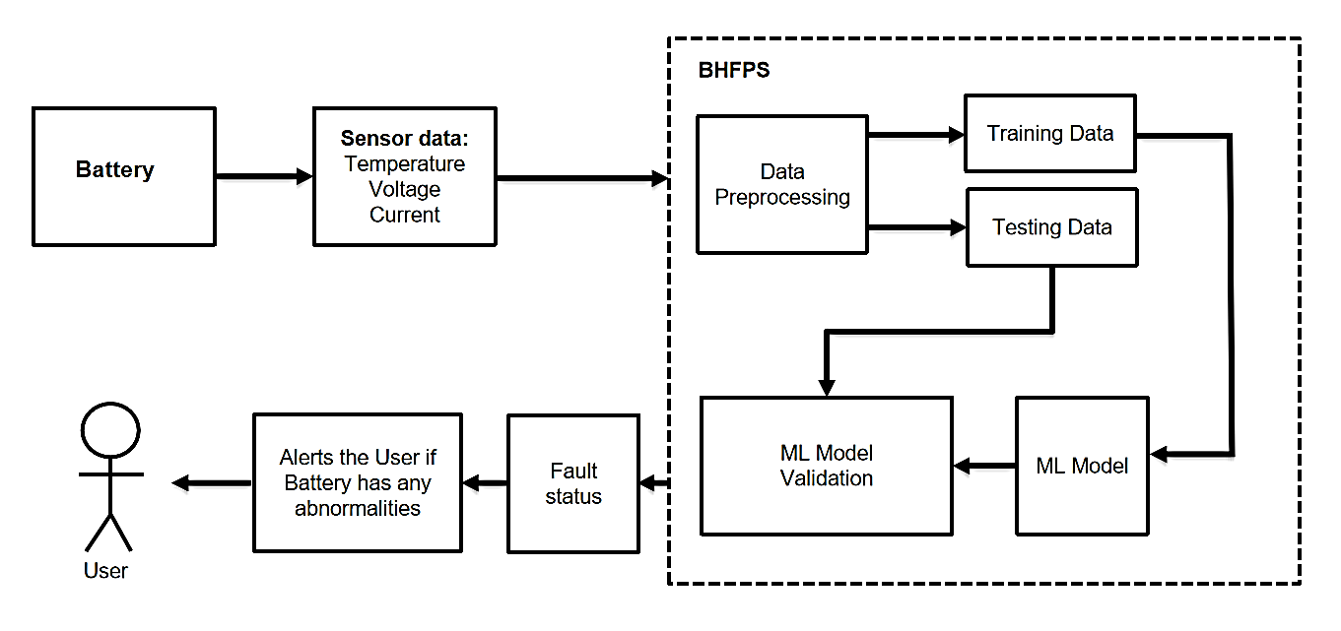

Fig. 1. Architecture Diagram

Second, the electrical potential across the battery cells is measured and recorded using voltage sensors. This information is crucial for evaluating the overall voltage levels and identifying variances that might point to anomalies or possible problems with the batteries. Finally, the presence of current sensors helps to keep an eye on how much electricity is entering and leaving the battery. These sensors monitor patterns of charging and discharging, giving vital information on the energy transfer mechanisms and the battery's state of operation. When combined, these sensors provide an extensive dataset that includes measurements of temperature, voltage, and current all of which are essential for comprehending the behaviour and efficiency of the EV batteries in real time. Accurate and ongoing collection of this diverse data serves as the foundation for further research and Proactive steps to guarantee battery health, safety, and dependability in EVs made possible by predictive modelling in the BHMFPS.

Data Processing and Analysis: Data processing and analysis are crucial steps in the collection and utilization of sensor data. Following the capture of raw data, preprocessing and data purification are often the first steps. This is an important step since raw data can contain noise, missing numbers, or anomalies from a range of sources, such as transmission issues, environmental factors, or malfunctioning sensors. Applying statistical analysis to the dataset facilitates the understanding of trends, correlations, and patterns. Techniques including time-series analysis, clustering, regression analysis, and classification can assist identify patterns and relationships in the data that might not be readily clear from the raw data. Finding complex patterns in large datasets is made possible by neural networks and other deep learning approaches, which is helpful for getting more insights about the data.

Machine learning and Integration: The ML model and integration module plays a critical role in the BHMFPS by harnessing the power of machine learning to analyse data collected from sensors within electric vehicle batteries. This module begins by training the ML model using historical data that includes information about various battery parameters such as temperature, voltage, and state of charge, along with corresponding indicators of battery health and potential faults. During the training phase, the ML model identifies patterns and trends within the data that are indicative of battery degradation or impending failures. These patterns may include gradual changes in voltage or temperature, sudden spikes in current draw, or deviations from expected charging and discharging behaviours. By learning from historical data, the ML model becomes capable of making accurate predictions or classifications about the health of the battery and the likelihood of future faults. Once trained, the ML model seamlessly integrates with the data preprocessing module to receive preprocessed data from sensors in real-time. This data includes current measurements of battery parameters that are cleaned, normalized, and prepared for input into the ML model. The ML model then analyses the incoming data and generates predictions or classifications based on the learned patterns and trends. These predictions may include estimates of remaining battery life, likelihood of imminent failures, or recommendations for preventive maintenance actions. By continuously analysing real-time data from sensors, the ML model enables the BHMFPS to provide timely insights and alerts to vehicle owners, maintenance personnel, or fleet managers, allowing them to take proactive measures to ensure the safety and reliability of electric vehicles.

Alerting System: The Alerting System, which is meant to recognize and alert users to any potential anomalies or battery flaws, is a crucial component of monitoring the sensor data output. This module is designed to continuously monitor the state of the integrated batteries within the system, since batteries are crucial to the reliability and functioning of many devices, including IoT configurations. The objective of the alerting system is to proactively identify any abnormalities or issues with the battery's operation. Sensor data related to battery state, such as temperature, charging cycles, voltage levels, or general health indications, are routinely analysed. Figure 3 shows the dashboard depicting various parameters and tis values. By setting preset thresholds or criteria for typical battery operating scenario, the system can immediately spot changes that may indicate failures or degradation. When abnormalities are discovered in the battery performance data, the alerting system notifies the user or other personnel who have been selected. The system uses many communication channels to ensure timely and effective notifications. These methods could include sending emails, SMS messages, push notifications to mobile devices or particular programs, or even initiating visual or auditory alerts on connected devices, depending on the requirements of the application.

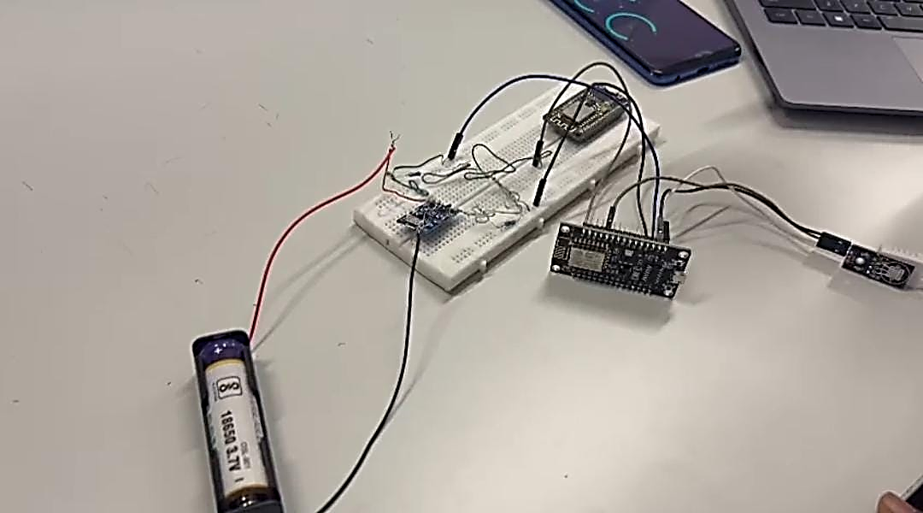

Fig. 2. Experimental Setup

## Screenshot (294)

Fig. 3. Dashboard

## Steps to Implement Machine Learning Model

Dataset and its Attributes: The provided dataset, comprising over 690,000 charging snippets from 347 EVs, offers a comprehensive exploration of real-world charging scenarios. These snippets encompass a range of battery parameters, including voltage, current, temperature, and State Of Charge (SOC). The temporal information in the form of timestamps suggests that the dataset likely spans various charging sessions, providing a diverse representation of charging behaviours across different times. Key attributes such as volt, current, and SOC provide crucial insights into the electrical characteristics of the charging process. The dataset goes beyond aggregated metrics by including max_single_volt and min_single_volt, indicating a detailed breakdown of individual battery cell voltages. This granularity allows for a more nuanced analysis of battery health, enabling the identification of potential issues at the cell level. The inclusion of max_temp and min_temp attributes further enhance the dataset's richness by capturing the temperature dynamics of the battery during charging. Temperature is a critical factor influencing battery performance and longevity, making this information valuable for understanding the charging environment's impact on overall battery health. The label attribute, indicating whether a snippet represents normal charging or contains an anomaly (fault), serves as the ground truth for training fault detection models. This supervised learning approach, leveraging the labelled instances, empowers the model to learn the normal charging patterns and identify deviations that may signal potential faults or abnormalities in the charging process. With its expansive size and diverse representation of charging scenarios, this dataset provides a robust foundation for training fault detection models capable of generalizing across different EV’s, charging segments, and usage patterns. The dataset's detailed attributes and ample size position it as a valuable resource for advancing research and development in electric vehicle battery health monitoring and anomaly detection.

Importing necessary libraries: In this step, we need to import the libraries or modules required for implementing machine learning models and performing data analysis.

Reading dataset: After importing the necessary libraries, we need to read the dataset into the Python environment. This involves loading the dataset from a file (e.g., CSV, Excel, JSON) using appropriate functions.

Splitting data: Before building and training machine learning models, it's essential to split the dataset into training and testing sets. The training set is used to train the model, while the testing set is used to evaluate its performance. This helps to assess how well the model generalizes to new, unseen data. Common techniques for splitting the data include random sampling or using cross-validation methods.

Models: After splitting data, the Machine Learning (ML) model undergoes several phases. First, it enters the training phase, where it learns from a designated portion of the dataset known as the training set. Here, the model absorbs patterns and relationships between input features and target variables. Following training, the model moves to the validation phase. In this stage, its performance is assessed using a separate portion of the data called the validation set. This evaluation helps fine-tune hyperparameters and prevent overfitting, ensuring the model's generalization to unseen data.

## Machine learning Models

Gaussian Naive Bayes (GNB) is a probabilistic classification algorithm that is based on Bayes’ theorem with the assumption of independence between features. It is commonly used for classification tasks, especially when dealing with large datasets. One of the key assumptions of the NB algorithm is that all features are independent of each other given the class label.

Logistic Regression (LR) is a statistical method used for binary classification tasks, where the target variable is categorical and has two possible outcomes (e.g., yes/no, true/false, 0/1). Despite its name, logistic regression is actually a classification algorithm, not a regression algorithm. It estimates the probability that a given instance belongs to a particular class using a logistic function. The logistic function (also known as the sigmoid function) maps any real-valued number to the range [0, 1], making it suitable for modelling probabilities.

K-Nearest Neighbours (KNN) is a non-parametric classification algorithm used for both classification and regression tasks. In the context of classification, KNN classifies instances based on their similarity to neighbouring instances in the feature space. The algorithm operates on the principle that instances with similar feature values are likely to belong to the same class. During the training phase of the KNN algorithm, the model stores the entire training dataset in memory. When a new instance is to be classified, the algorithm calculates the distance between the new instance and all instances in the training dataset using a distance metric such as Euclidean distance or Manhattan distance. It then selects the KNN (instances with the smallest distances) and assigns the majority class label among these neighbours to the new instance.

# Experimental Results and Discussions

The deployment of the BHMFPS has resulted in notable advancements in augmenting the dependability and security of electric vehicles. Utilizing an IoT system to continuously monitor voltage, current, and temperature, among other factors, the system showed an astonishing capacity to anticipate future problems or anomalies in lithium-ion batteries. This preventive strategy greatly reduced the risks of battery failures and the possibility of disastrous catastrophes like explosions or large losses as a result of battery-related incidents. Predictive maintenance strategies and real-time monitoring introduced a level of security and increased the overall dependability of EVs.

## K-Nearest Neighbors (KNN)

KNN’s classification report is exhibited in Table 1. KNN achieved an impressive accuracy of 99% on the testing dataset, indicating correct classification of 99% of instances. This high accuracy is reflected in the precision and recall scores. The precision values for the classes are [0.47, 0.99, 1.0], indicating that the model correctly classified the majority of instances for each class, with particularly high precision for the second and third classes. Similarly, the recall values [1.0, 0.99, 0.0] demonstrate the model's ability to identify instances of each class, although it struggles with the third class, possibly due to a lack of representative samples. The F1 score, a harmonic mean of precision and recall, further supports the model's strong performance, yielding a value of 0.99. The confusion matrix illustrates the model's classification results, showing minimal misclassifications with only 38 instances wrongly classified for the first class and 57 for the second class. KNN’s Precision Recall Curve (PRC) is highlighted in the Figure 4.

1. KNN Classification Report

|  |  |  |  |
| --- | --- | --- | --- |
|  | **Precision** | **Recall** | **F1-score** |
| **0 (No Fault)** | 0.99 | 0.99 | 0.99 |
| **1 (Fault)** | 0.99 | 0.99 | 0.99 |
| **Accuracy** | 0.99 | | |
| **Macro Avg.** | 0.99 | 0.99 | 0.99 |
| **Weighted Avg.** | 0.99 | 0.99 | 0.99 |

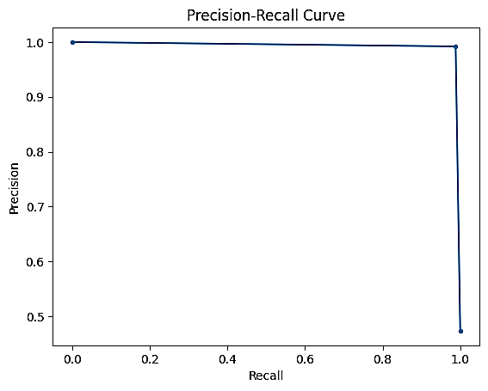

Fig. 4. KNN’s PRC

## Logistic Regression (LR)

Table 2 emphasis the LR’s classification report. LR demonstrated an accuracy of 67% on the testing dataset, indicating that it correctly classified 67% of the instances. This accuracy is complemented by precision and recall scores. Precision values for the classes are [0.47, 0.65, 1.0], suggesting that the model correctly classified the majority of instances for each class, albeit with lower precision compared to KNN. The recall values [1.0, 0.71, 0.0] highlight the model's ability to identify instances of each class, with particularly high recall for the first class and a moderate recall for the second class. The F1 score, a harmonic mean of precision and recall, further confirms the model's performance, yielding a value of 0.68. LR’s PRC is represented in the Figure 5.

1. LR’s Classification Report

|  |  |  |  |
| --- | --- | --- | --- |
|  | **Precision** | **Recall** | **F1-Score** |
| **0 (No Fault)** | 0.71 | 0.65 | 0.68 |
| **1 (Fault)** | 0.65 | 0.71 | 0.68 |
| **Accuracy** | 0.68 | | |
| **Macro Avg.** | 0.68 | 0.68 | 0.68 |
| **Weighted Avg.** | 0.68 | 0.68 | 0.68 |

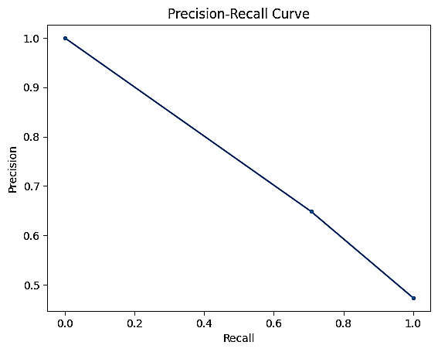

Fig. 5. LR’s PRC

## Gaussian Naive Bayes (GNB)

GNB achieved an accuracy of 69% on the testing dataset is depicted in Table 3, signifying correct classification for 69% of the instances. While this accuracy may appear moderate compared to other classification algorithms, Gaussian Naive Bayes is esteemed for its simplicity and computational efficiency. Despite relying on strong independence assumptions between features, the model performed adequately, particularly notable for datasets with continuous features and large sample sizes. Precision values for the classes are [0.47, 0.65, 1.0], indicating that the model correctly classified the majority of instances for each class. The recall values [1.0, 0.77, 0.0] highlight the model's ability to identify instances of each class, with particularly high recall for the first and second classes. The F1 score, a harmonic mean of precision and recall, further supports the model's performance, yielding a value of 0.71. Figure 6 exhibits the behavior of GNB’s PRC.

1. GNB’s Classification report

|  |  |  |  |
| --- | --- | --- | --- |
|  | **Precision** | **Recall** | **F1-Score** |
| **0 (No Fault)** | 0.76 | 0.63 | 0.68 |
| **1 (Fault)** | 0.65 | 0.77 | 0.71 |
| **Accuracy** | 0.70 | | |
| **Macro Avg.** | 0.70 | 0.70 | 0.70 |
| **Weighted Avg.** | 0.71 | 0.70 | 0.70 |

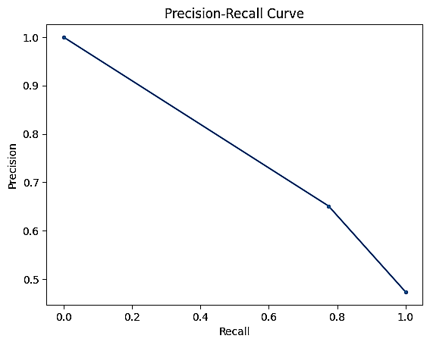

Fig. 6. GNB’s PRC

# Conclusion and Future Enhancement

By leveraging ML models trained on data collected from IoT sensors, the system showcased an impressive capability to enhance the safety and reliability of EV. An essential stride in achieving this improvement is the implementation of BHMFPS, a proactive strategy to mitigate potential hazards associated with lithium-ion battery failures by integrating an IoT-based monitoring system. This system continuously gathers and analyses crucial metrics such as voltage, current, and temperature, demonstrating an advanced approach to preventive maintenance. The BHMFPS’s capacity to anticipate issues and dispatch real-time notifications plays a pivotal role in preventing catastrophic events, establishing a new level of safety and dependability for EVs. Furthermore, the dynamic and ongoing monitoring of battery health enables early detection of abnormalities, facilitating prompt actions and proactive maintenance measures. The application of complex algorithms, most notably the KNN model, demonstrated extraordinary accuracy, with a 99% fault prediction rate, than the remaining approaches. Its strong performance highlights the importance of early fault detection and shows how to take preventative measures to deal with possible safety risks related to battery failures. By utilizing a complex examination of vital indicators such as voltage, current, and temperature, the system has demonstrated its ability to precisely detect anomalies that may result in significant issues with EV battery systems. Pre-emptive measures are made possible by the capacity to deliver timely alarms and warnings based on predictive analysis, guaranteeing the dependability and safety of EV battery systems. By identifying problems before they worsen, this concept not only improves safety but also makes proactive maintenance possible, which could lengthen the life of EV batteries. Examining hybrid models or RNNs as deep learning models may improve fault prediction's resilience and accuracy. Moreover, the incorporation of more complex anomaly detection methods, like deep learning approaches or powerful AI algorithms, may improve the accuracy of defect prediction.

##### References

1. Zhang, J., Wang, Y., Jiang, B, “Realistic fault detection of li-ion battery via dynamical deep learning”. Nat Comm. 14, 5940, 2023.
2. Bhaskar K, Kumar A, Bunce J, Pressman J, Burkell N, Rahn CD. “Data-Driven Thermal Anomaly Detecion in Large Battery Packs”. Batteries. vol. 9, no. 2,, 2023.
3. H. Chunhua, H. Ren, W. Runcai and Y. Jianbo, “Fault Prediction and Fault-Tolerant of Lithium-ion Batteries Temperature Failure for Electric Vehicle,” 2012 Third International Conference on Digital Manufacturing & Automation, Guilin, China, 2012, pp. 410-413.
4. K. Zhang, X. Hu, Y. Liu, X. Lin and W. Liu, “Multi-fault Detection and Isolation for Lithium-Ion Battery Systems”, in IEEE Transactions on Power Electronics, vol. 37, no. 1, pp. 971-989, Jan. 2022.
5. Ting Cai, Peyman Mohtat, Anna G. Stefanopoulou, Jason B. Siegel, “Li-ion Battery Fault Detection in Large Packs Using Force and Gas Sensors”, IFAC-PapersOnLine, vol. 53, no. 2, pp. 12491-12496, 2020.
6. D. Li, Z. Zhang, P. Liu, Z. Wang and L. Zhang, “Battery Fault Diagnosis for Electric Vehicles Based on Voltage Abnormality by Combining the Long Short-Term Memory Neural Network and the Equivalent Circuit Model”, in IEEE Trans. Power Electr. vol. 36, no. 2, pp. 1303-1315, 2021.
7. X. Gu, Y. Shang, Y. Kang, J. Li, Z. Mao and C. Zhang, “An Early Minor-Fault Diagnosis Method for Lithium-Ion Battery Packs Based on Unsupervised Learning”, in IEEE/CAA J. Automatica Sinica, vol. 10, no. 3, pp. 810-812, March 2023.
8. Jing Sun, Song Ren, Yunlong Shang, Xiaodong Zhang, Yiwei Liu, Diantao Wang, “A novel fault prediction method based on convolutional neural network and long short-term memory with correlation coefficient for lithium-ion battery”, J. Energy Storage, vol. 62, no. 106811, 2023.